
Rollback
Robert J. Sawyer
0-765-31108-9
(hc) $29.95
320 pages
Science Fiction

Published by Tor Books
Distributed in Canada by
H.B. Fenn and Company

CONTACT:
Janis Ackroyd
Publicity Manager
905.951.6600 x 276
janis.ackroyd@hbfenn.com
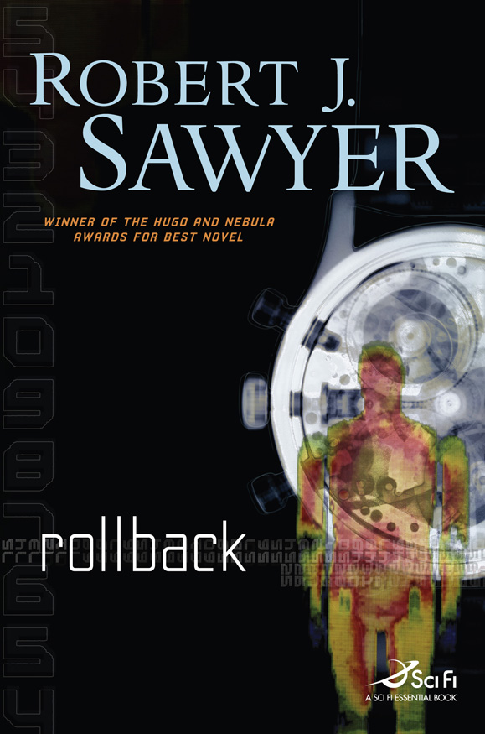

“Canadian author Sawyer (Mindscan) once again presents likeable characters facing big ethical dilemmas in this smoothly readable near-future SF novel…Sawyer, who has won Hugo and Nebula awards, may well win another major SF award with this superior effort.” —Publishers Weekly (starred review)

A new novel by Canada’s leading Science Fiction author, Robert J. Sawyer

ROLLBACK

Dr. Sarah Halifax decoded the first-ever radio transmission received from aliens. Thirty-eight years later, a second message is received and Sarah, now eighty-seven, may hold the key to deciphering this new communication, but many fear she is too old…

Cody McGavin, a wealthy industrialist, offers Sarah a rollback—an expensive procedure that can rejuvenate a person, restoring them to the physical and mental vigor they had when they were in their twenties. Sarah refuses to accept unless her husband Don is allowed a rollback too. McGavin agrees and the procedure works for Don, but fails for Sarah. Suddenly, after six decades of marriage, Don is back to being physically twenty-five while Sarah is still eighty-seven.

While Don adjusts to his newfound youth and the sudden vast age gap between him and his wife, Sarah struggles to figure out what the new message from the aliens contains. Will she have time to decode the message before her time on earth runs out?

Set in Toronto in the future, Rollback explores morals and ethics on both human and cosmic scales. It is also an exploration of the power of commitment and love.

Observations on the future:

- Robots, a.k.a. Mozos, exist to help the elderly do daily tasks such as housecleaning, driving, and fetching a cup of coffee.
- The Canadian health care system is in good shape. Procedures that cost hundred of thousands of dollars now cost a tiny fraction of that and pharmaceuticals are inexpensive. Safe, virtually infallible, over-the-counter birth-control drugs are available for both men and women. AIDS and Cancer have been conquered.
- In 2067, Canada turns 200 and celebrates by hosting a world’s fair.


Robert J. Sawyer is one of only seven writers in history—and the only Canadian—to win the world’s top three science-fiction awards for best novel of the year: the Nebula, which is voted on by writers; the Hugo, which is voted on by readers; and the John W. Campbell Memorial Award, which is the field’s major juried award. He’s received an honorary doctorate from Laurentian University and the Alumni Award of Distinction from Ryerson University. He lives in Mississauga. Visit his website at sfwriter.com.

Short Excerpt:

Dr. Petra Jones confirmed that his rollback was complete. His cell-division rate, she said, had slowed to normal and his telomeres had gone back to shortening with each division, a new set of growth rings was starting to appear in his bones, and so on. And the follow-up work had been completed, too. He had new lenses, a new kidney, and a new prostate, all grown from his own cells; his nose was restored to the merely honker-esque proportions it’d had in his youth; his ears had been reduced; his teeth had been whitened and his two remaining amalgam fillings replaced; and a few nips and tucks had tidied up other things. For all intents and purposes, he was physically twenty-five once more, and aging forward normally from that point.

Don was still getting used to all the wonderful improvements. His hearing was top-notch again, as was his vision. But he’d had to buy a whole new wardrobe. After the recalcification treatments and gene therapies, he’d regained the two inches he’d lost over the years, and his limbs, which had been reduced to not much more than skin and bones, had beefed up nicely. Ah, well; his collection of cardigans and shirts with buttons would have looked silly on a guy apparently in his twenties.

At some point, he’d also have to get a new passport, with his new face, and new credit cards, also with his new face. Technically, he’d still be entitled to seniors’ discounts in restaurants and at movies, but there’d be no way to claim them without convincing incredulous waiters and clerks. Too bad, really. Unlike, he was sure, every other person who had undergone a rollback, he really could use the break.

